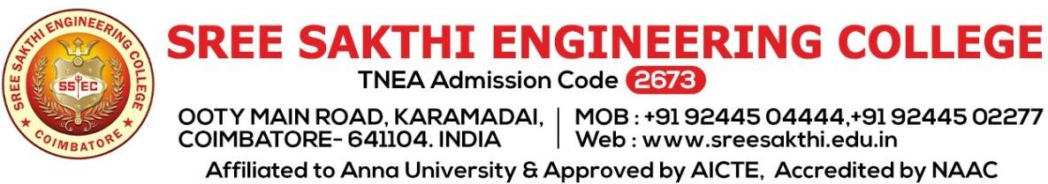

3.2.1
INSTITUTION HAS CREDITED AN ECOSYSTEM FOR INNOVATIONS

SEMINAR ON “ENTERPRENERSHIP” FOR EEE DEPARTMENT STUDENTS”
Entrepreneurship is the ability and readiness to develop, organize and run a business enterprise, along with any of its uncertainties in order to make a profit. The most prominent example of entrepreneurship is the starting of new businesses.
DETAIL REPORT OF COURSE:
Title : SEMINAR ON “ENTERPRENERSHIP”
Date : 10.3.23
Venue : Power system simulation Lab
Target audience: II, III & IV year EEE students
Resource Person :Mr.CKannan, VEI TECHNOLOGIES Pvt. Ltd., Chennai,
OBJECTIVE OF PROGRAM:
The basic principles of entrepreneurship are:
- Planning a business: While launching a startup, you need to smartly build strategies for establishing the startup. This involves building a vision, assessing financial risks, gathering team members, and planning out a contingency plan. Without a proper plan, a business is likely to face losses and failures.
- Starting a business: After planning the administration and management of the business, entrepreneurs can start the business. To start a business venture, owners will have to first register the company and complete legal formalities. They will also need to have a space to start the business operation.
- Operating a business: Once this entrepreneurial venture has been brought legally into existence, it will need capital to fund operations. Entrepreneurs can either bootstrap or invest venture capital in the business. After the business has its working capital, a team must be built, logistics should be managed and processes must be planned.
TOPICS COVERED IN TRAINING:
- Small businesses entrepreneurship: It is a small-cap business that does not turn into a multi-chain organization or a large conglomerate. Small-scale entrepreneurship is initiated through bootstrapping, giving the owner a complete right to profits. In such ventures, entrepreneurs take loans to run the business.
- Scalable startup entrepreneurship: Such a startup is started with high ambitions, including making profits and achieving high growth. For such types of entrepreneurship, there is a requirement for huge funds that require large external investments. These startups aim to compete with established and successful companies.
- Large company entrepreneurship: This type of entrepreneurship is suitable for those owners that have experience of sustaining innovation. Often C-level executives opt for this type of venture. This is the new division created within an established and larger company to offer new variants of its core products. It is an adaption to environment expansions.
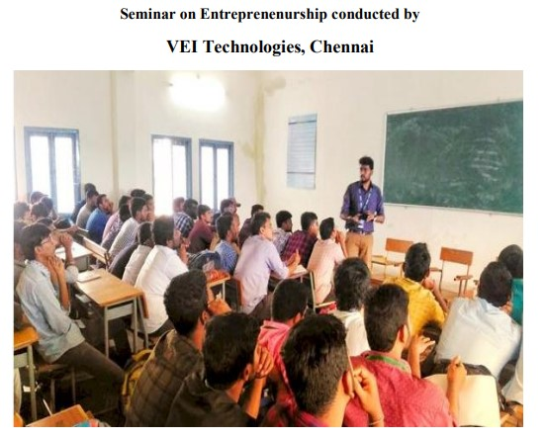

SEMINAR ON “MOTOR CONTROL AND INDUSTRIAL COMPONENT” FOR EEE DEPARTMENT STUDENTS”
The main objective of this course is to promote that For every motor, some form of electrical control is required, from simple ON/OFF to more complex variable speed applications. Motor control devices encompass simple manual controllers, motor contactors and starters, drives and soft starters.
DETAIL REPORT OF COURSE:
Title : MOTOR CONTROL AND INDUSTRIAL COMPONENT
Date : 19.09.22
Venue : Electrical Machines Lab
Target audience: II, III & IV year EEE students
Resource Person :Mr.J.Kumarasamy, SALZER ELECTRONICS,COIMBATORE

OBJECTIVE OF PROGRAM:
The purpose of a motor control system is to control one or more of the motor output parameters, that is, shaft speed, angular position, acceleration, shaft torque, and mechanical output power. The control of temperature at various points in the motor is also a frequent objective of motor control systems.

TOPICS COVERED IN TRAINING:
- AC motor Controller
- DC motor Controller
- Servo motor controller
- Motor Controllers and Drives — Applications and Industries

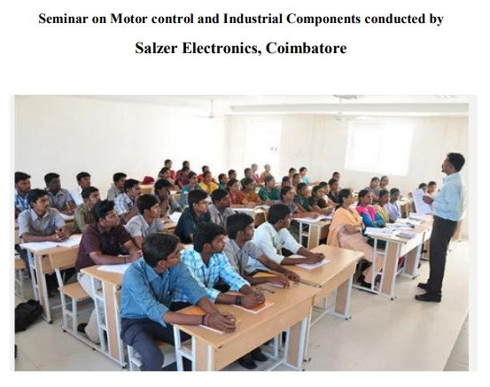

“PCB DESIGN FOR EEE DEPARTMENT STUDENTS”
The goal is to generate a set of files that are used to fabricate and assemble the PCB. If taken time to gather all functional and performance requirements for the new product, and need to design a high-quality PCB for thedevice, then ready to move through the PCB design process. These courses are compliance to industry standard so that they have a simulated experience of the industry.
DETAIL REPORT OF COURSE:
Title : PCB DESIGN
Date : 20.12.23
Venue : ENGINEERING PRACTICES LAB
Target audience: II, III & IV year EEE students
Resource Person :Mr.M.KrishnaKumar, ABE SEMICONDUCTOR DESIGN , Coimbatore

OBJECTIVE OF PROGRAM:
- Understand what a PCB is and how it functions.
- Know the relevant standards which govern PCB installations.
- Be able to read and understand design.
- Involves the creation of electrical schematics and drawings that show how components are interconnected.

TOPICS COVERED IN TRAINING:
- PCB Layer fabrication data in Gerber, ODB++, or IPC-2581 file formats
- Pick and place files denoting component locations for assembly
- PCB fabrication and assembly drawings, including notes listing requirements
- A complete BOM with electronic component sourcing information
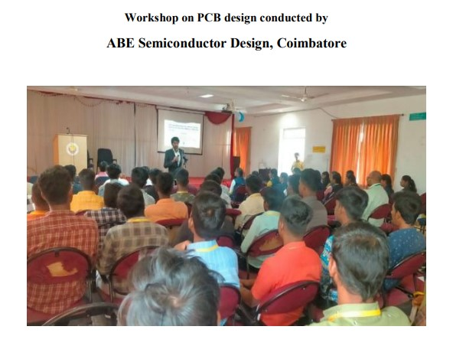
- A report with testing information, such as test point data and test point locations
WORSHOP ON INDUSTRIAL DRIVES AND CONTROL FOR EEE DEPARTMENT STUDENTS
The main objective of this course is about efficient semiconductors optimized for motor control. You can rely on our intelligent power modules (IPMs) and discretes for smart designs in the low-power range. For medium-power drives, our EasyPIM™, EasyPACK™, and EconoPIM™ modules are the perfect match. Moving on to the high-power spectrum, EconoDUAL™ and PrimePACK™ are the solutions of choice. Combined with the innovative.XT interconnection technology, PrimePACK™ modules can help designers overcome the overrating dilemma as they extend the lifetime by raising thermal and power cycling capabilities.. These courses are compliance to industry standard so that they have a simulated experience of the industry.
DETAIL REPORT OF COURSE:
Title : INDUSTRIAL DRIVES AND CONTROL
Date : 14.2.23
Venue : Power electronics Lab
Target audience: II, III & IV year EEE students
Resource Person :Mr.Bharath,ABE SEMICONDUCTOR DESIGN, Coimbator
OBJECTIVE OF PROGRAM:
- Understand what is industrial drives and how it functions.
- Know the relevant standards which govern drives installations.
- Be able to read and understand control of drives.
- Understand how drives areoperated in a system
TOPICS COVERED IN TRAINING:
- The handling of development tools.
- Basic knowledge about the structure of the embedded software, configuration and parameterization of hardware.
- Simulation and Modeling
- An overview Embedded system designusing IOT.

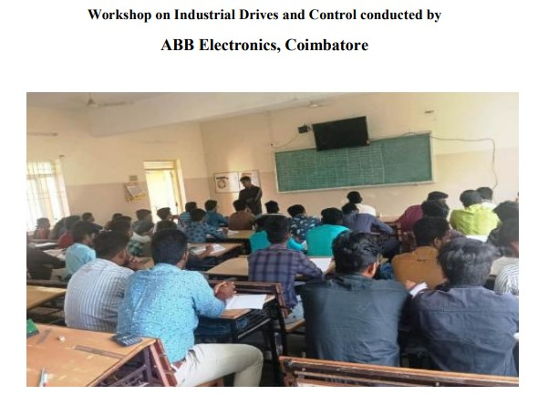

1. INNOVATION ON 5G NETWORKS FOR CSE DEPARTMENT STUDENTS
5G networks are the latest generation of mobile internet connectivity, offering faster speeds and more reliable connections on smartphones and other devices than ever before. The "G" in 5G stands for "generation," and each previous generation has brought significant advancements in mobile technology:
1G was the first generation of mobile technology, enabling analog voice calls.
2G introduced digital voice calls and text messaging.
3G brought mobile data, allowing for internet browsing and email on mobile devices.
4G (LTE) significantly increased mobile internet speeds, enabling HD video streaming and video calls.
DETAIL REPORT OF COURSE:
Title : INNOVATION ON 5G NETWORKS
Date : 22.07.22
Venue : COMPUTER CENTER-1 Lab
Target audience: CSE students
Resource Person: Mr.RajKumar., CEO, Webnox Technologies.Coimbatore.
OBJECTIVES OF THE PROGRAM
Faster Speeds: 5G can deliver speeds up to 10 gigabits per second (Gbps), significantly faster than 4G. Lower Latency: The time it takes for devices to communicate with each other over the network is greatly reduced with 5G, which is crucial for applications like online gaming and autonomous vehicles. More Connections: 5G networks can support more devices per square kilometer, making it ideal for densely populated areas and the Internet of Things (IoT).
Enhanced Connectivity: The technology behind 5G allows for more stable connections, even in crowded places like stadiums or concert venues.
5G Architecture and Components: Understanding the architecture of 5G networks, including the Radio Access Network (RAN), Core Network, and how they work together to provide connectivity.
5G Network Slicing: Exploring the concept of network slicing in 5G, which allows operators to create multiple virtual networks with different characteristics to meet the needs of different applications.
5G Radio Access Technologies: Learning about the different radio access technologies used in 5G, including mmWave, sub-6 GHz, and Massive MIMO, and their impact on network performance.
5G and Edge Computing: Exploring the integration of 5G networks with edge computing technologies to enable low-latency applications and services.
5G Use Cases: Studying the various use cases of 5G technology across different industries, such as healthcare, manufacturing, and transportation.
5G Standards and Regulatory Framework: Understanding the global standards and regulatory frameworks governing 5G deployment and operation.
5G Network Performance and Optimization: Learning about the factors that affect the performance of 5G networks, such as signal propagation, interference, and network capacity, and how they can be optimized.

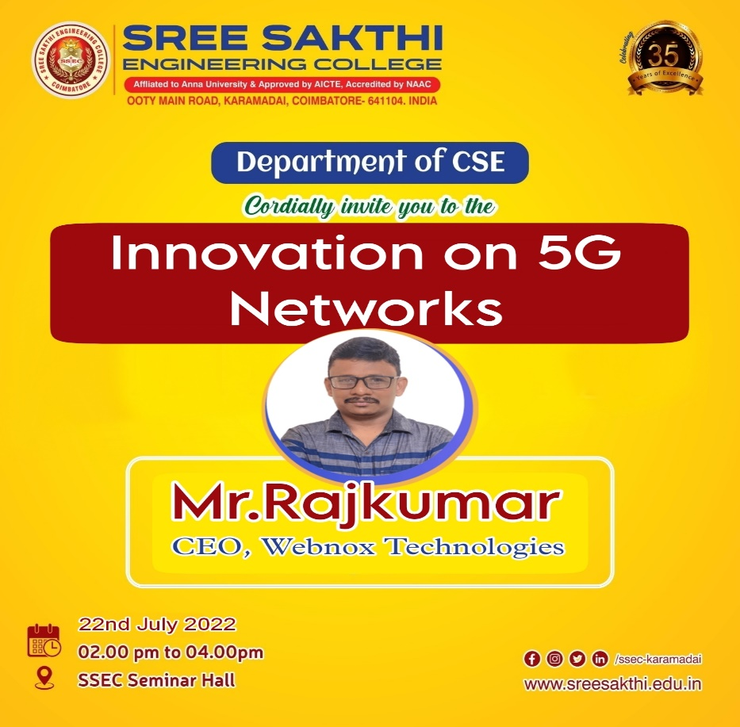



STAFF INCHARGE HOD

2.ECOSYSTEM ON BLOCKCHAINFOR CSE DEPARTMENT STUDENTS
An "ecosystem on block chain" refers to a network of interconnected block chain-based applications, platforms, and services that work together to provide a range of functionalities and services.
DETAIL REPORT OF COURSE:
Title : ECOSYSTEM ON BLOCKCHAIN
Date : 16.03.23
Venue : COMPUTER CENTER-1 Lab
Target audience: CSE students
Resource Person: Mr.Iyyappan., Web Developer, Webnox Technologies. Coimbatore.
OBJECTIVES OF THE PROGRAM
Here are some key aspects of an ecosystem on block chain:
Decentralization: The ecosystem is decentralized, meaning that there is no single point of control or failure. This ensures greater transparency, security, and resilience.
Interoperability: Different block chain networks and applications within the ecosystem can communicate and interact with each other, enabling seamless data exchange and collaboration.
Tokenization: Tokens are used within the ecosystem to represent value, ownership, or access rights. These tokens can be used to incentivize users, facilitate transactions, and govern the ecosystem.
Smart Contracts: Smart contracts are self-executing contracts with the terms of the agreement directly written into code. They automate and enforce the rules and agreements within the ecosystem.
DApps (Decentralized Applications):DApps are applications that run on a block chain network, rather than a centralized server. They enable various functionalities and services within the ecosystem.
Governance: The ecosystem may have a governance mechanism in place to manage and make decisions about the network, such as protocol upgrades, resource allocation, and dispute resolution.
Regulatory Compliance: Addressing regulatory requirements and ensuring that the ecosystem complies with relevant laws and regulations.
Overall, an ecosystem on block chain creates a decentralized, transparent, and efficient environment for a wide range of applications and services.

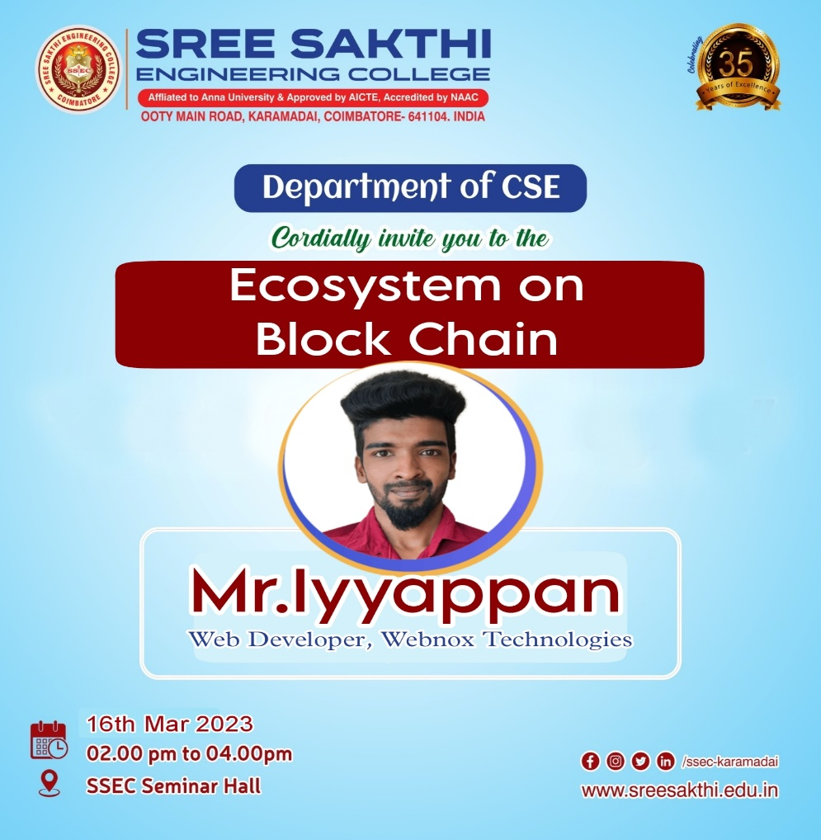

STAFF INCHARGE HOD

WORKSHOP ON “STRUCTURAL DESIGN BY USING STAAD PRO”

STAAD.Pro is used to analyse structures made of a variety of materials, and simulate different loads that structures are subjected to. The Structural design is the methodical investigation of the stability, strength and rigidity of structures. The basic objective of this workshop is students can understand the structural analysis and design knowledge to produce a structure capable of resisting all applied loads without failure during its intended life.

DETAIL REPORT OF COURSE:
Title : “STRUCTURAL DESIGN BY USING STAAD PRO”
Date : 02.02.2023
Venue : CIVIL CAD LAB
Target audience: III & IV year Civil Engineering students
Resource Person:Mr.B.Arunkumar, Cad Designer, Alphabet, Chennai.

OBJECTIVE:
- To study the introduction about STADD Pro software.
- To analysing & designing structures like – buildings, towers, bridges, industrial, transportation and utility structures.
- To create and analyze single and multi storey building by using STADD Pro.

TOPICS COVERED IN WORKSHOP:
- Overview of Structural Analysis and Design
- Geometry creation Methods.
- Introduction to RCC Design as per IS 456.
- Calculation of Wind load as per IS 875 Part 3.

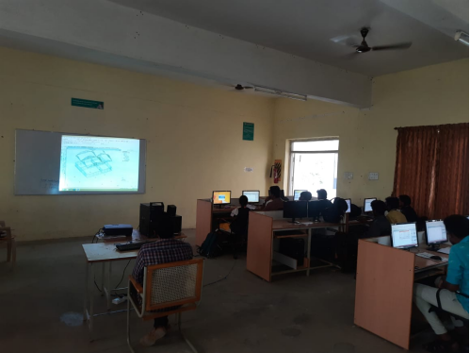
WORKSHOP ON “CONSTRUCTION SAFETY MANAGEMENT”

Construction safety management is most important which is used to control safety activities in order to ensure a safe working environment in the construction site. The basic objective of this workshop is students can understand the various safety aspects in construction site.

DETAIL REPORT OF COURSE:
Title : “CONSTRUCTION SAFETY MANAGEMENT”
Date : 09.09.2023
Venue : Seminar Hall
Target audience: III & IV year Civil Engineering students
Resource Person:Mr. J. Madhankumar, Senior Site Engineer, Kosapat, Chennai.

OBJECTIVE:
- To articulate the importance of safety on the construction site.
- To upgrade skills in Construction Contracts Management and help them to grow in their career.

TOPICS COVERED IN WORKSHOP:
- Introduction to Construction Industry, Safety issues in construction - Human factors in construction safety management.
- Safety in various construction operations
- Safety in material handling and Equipment’s
- Contract Labor (R&A) Act and Central Rules

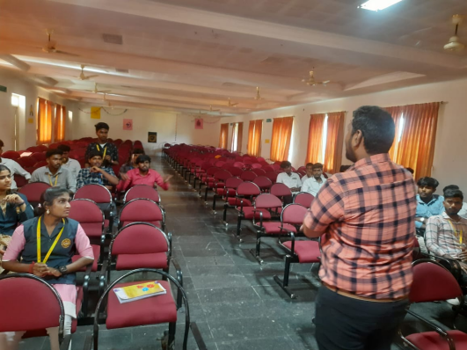

SEMINAR ON “CIVIL ENGINEERING DRAWING AND BAR BENDING SCHEDULE”
A bar bending schedule (BBS) is a tabular breakdown of reinforcing bars that includes details such as bar type, total length, weight and a drawing of the desired bending shape. Generally a bar bending schedule is developed for every different kind of RCC operation. The basic objective of this seminar is students can get the knowledge of Civil Engineering drawing and Bar Bending schedule.

DETAIL REPORT OF COURSE:
Title : “CIVIL ENGINEERING DRAWING AND BAR BENDING SCHEDULE”
Date : 23.03.2023
Venue : Construction site office
Target audience: III Year Civil Engineering students
Resource Person:Mr.R Ram Kumar, Cad Designer, Om Sai Buildings

OBJECTIVE:
- To Impart Knowledge about Bar Bending Schedule.
- To learn about Civil Engineering Drawing and Bar Bending Schedule.
- To get the knowledge to prepare Bar Bending Schedule.

TOPICS COVERED IN SEMINAR:
- Introduction to Civil Engineering Drawing and Bar Bending Schedule and its importance. Personnel using the Bar Bending Schedule
- Information given by the Bar Bending Schedule.
- Steps involved in the preparation of Bar Bending Schedule and Rebar work.

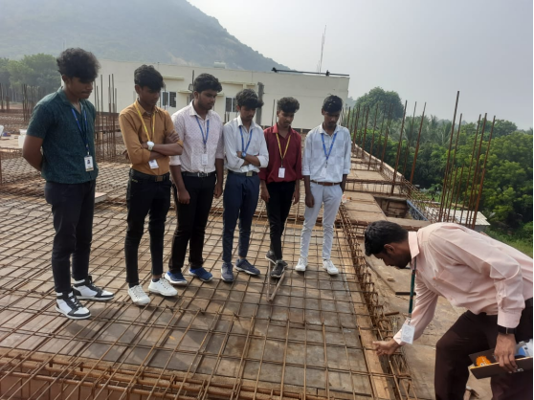
SEMINAR ON “3D MODELING AND SKETCHUP”

3D modelling creates a compelling visual experience allowing engineers to analyse and visualize designs with real world context. This aids in the overall design process and can prevent issues during construction. The basic objective of this seminar is students can understand the 3D Modelling and sketch up processes.

DETAIL REPORT OF COURSE:
Title : “3D MODELING AND SKETCHUP”
Date : 11.02.2023
Venue : CIVIL SEMINAR HALL
Target audience: III & IV year Civil Engineering students
Resource Person: Mr.r.Udhayashankar, Managing Director, B.T.R Construction, Erode

OBJECTIVE:
- To design and visualize complex infrastructure projects.
- To create detailed models of roads, bridges, buildings and other infrastructure elements.

TOPICS COVERED IN SEMINAR:
- Introduction to 3D Modelling and SketchUp tools.
- How to create a 3D model in Sketch Up.
- How to use that model to create construction documents in Layout.

